SECURE MEDICAL TRANSCRIPTION

2022

USING BLOCKCHAIN

**Literature Review**

* **Medical Transcription Confidentiality Breach**
* **Blockchain in Medical Transcription**

Gowtham Prasad S

17MSS018

**What is Medical Transcription?**

Medical transcription, also known as MT, is an allied health profession dealing with the process of transcribing voice-recorded medical reports that are dictated by physicians, nurses and other healthcare practitioners. Medical reports can be voice files, notes taken during a lecture, or other spoken material. These are dictated over the phone or uploaded digitally via the Internet or through smart phone apps.

Medical transcription as it is currently known has existed since the beginning of the 20th century when standardization of medical records and data became critical to research. At that time, medical stenographers recorded medical information, taking doctors' dictation in shorthand. With the creation of audio recording devices, it became possible for physicians and their transcribers to work asynchronously.



**Process of Medical Transcription**

When the patient visits a doctor, the latter spends time with the former discussing their medical problems and performing diagnostic services. After the patient leaves the office, the doctor uses a voice-recording device to record information about the patient encounter. This information may be recorded into a hand-held cassette recorder or into a regular telephone, dialed into a central server located in the hospital or transcription service office, which will 'hold' the report for the transcriptionist. This report is then accessed by a medical transcriptionist, who then listens to the dictation and transcribes it into the required format for the medical record, and of which this medical record is considered a legal document. The next time the patient visits the doctor, the doctor will call for the medical record or the patient's entire chart, which will contain all reports from previous encounters. The doctor can on occasion refill the patient's medications after seeing only the medical record, although doctors prefer to not refill prescriptions without seeing the patient to establish if anything has changed.

It is very important to have a properly formatted, edited, and reviewed medical transcription document. If a medical transcriptionist accidentally typed a wrong medication or the wrong diagnosis, the patient could be at risk if the doctor (or their designee) did not review the document for accuracy. Both the doctor and the medical transcriptionist play an important role to make sure the transcribed dictation is correct and accurate. The doctor should speak slowly and concisely, especially when dictating medications or details of diseases and conditions.

|  |
| --- |
| **Disadvantages of Medical Transcription** |
| * ***Technical Issue:*** As with any technology-based business, transcription companies are vulnerable to various technical issues. These issues can range from server failures, data drive malfunctions and communications breakdowns to software errors. |
| * ***Lack of Training:*** Despite the internal training processes of each medical transcription company, there is no industry-wide training that holds companies to a set standard. Most companies don’t provide formal training for medical transcription |
| * ***High Price:*** Many medical transcription companies offer tiered payment systems where physicians can pay for a faster turnaround time on their medical notes. Ignoring the quality concerns that rushed notes may produce, these tiered systems mean that you will almost always have to pay the highest price or risk losing your place in line to someone who is willing to pay. |
| * ***Misunderstandings and Report Quality:*** Humans make errors, misunderstand, and mistakenly allow things to slip through the cracks. They mistakenly misunderstand some words and it may affect the quality of the medical report. |
| * ***Regulatory Compliance:*** The transcripts may not be well-revised with the federal, state and government regulations that can be an issue later. It is seen that regulatory compliance needs to continuous accountability and reporting. |

**Medical Transcription Confidentiality breach:**

Medical transcribers deal with sensitive health information and they have specific obligations that are often protected by the law. Like others who deal with medical information, medical transcribers are required to observe privacy and confidentiality laws, along with any other rules and procedures set out by their employer or contracting business.

* Breaches in medical records can refer to a wide range of security issues that endanger a patient’s confidentiality and trust in an organization. At its core, a data breach occurs anytime information is accessed without authorization.
* In 2019, over 41 million patient medical records were breached especially by hackers.
* Hackers can profit off of sensitive information by stealing identities and even selling patient data on the dark web.
* Examples of breaches of medical information privacy or confidentiality can include talking to someone in a public place about what you’ve been transcribing or discussing it with family or friends.
* Another example of breach can be failure to protect personal information from misuse or unauthorized access.
* It also includes physical breaches like rogue employees, careless attention, unattended assets and areas.

**What is Blockchain?**

Blockchains are tamper evident and tamper resistant digital ledgers implemented in a distributed fashion (i.e., without a central repository) and usually without a central authority (i.e., a bank, company or government). At their basic level, they enable a community of users to record transactions in a shared ledger within that community, such that under normal operation of the blockchain network no transaction can be changed once published. Blockchains are distributed digital ledgers of cryptographically signed transactions that are grouped into blocks. Each block is cryptographically linked to the previous one (making it tamper evident) after validation and undergoing a consensus decision. As new blocks are added, older blocks become more difficult to modify (creating tamper resistance). New blocks are replicated across copies of the ledger within the network, and any conflicts are resolved automatically using established rules.

The whole point of using a blockchain is to let people — in particular, people who don't trust one another — share valuable data in a secure, tamperproof way – MIT on Blockchain.

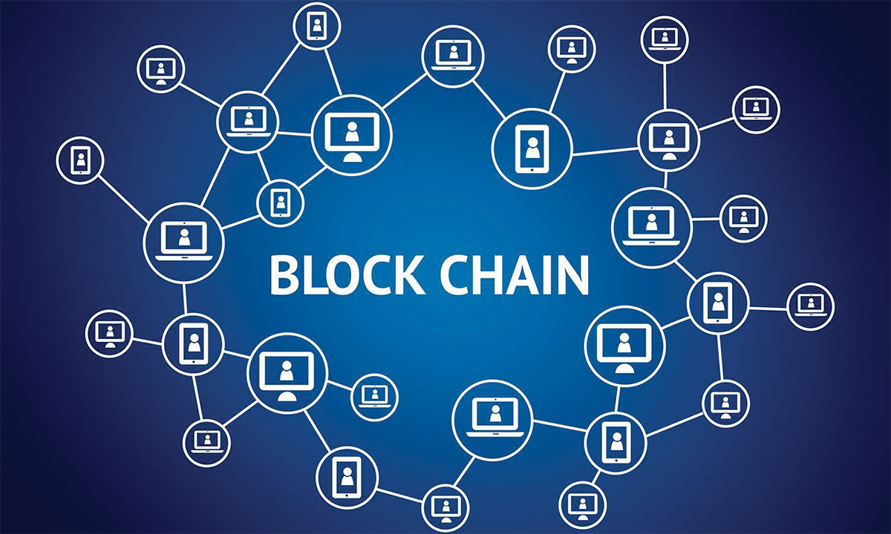

**Working of Blockchain**

Blockchain consists of three important concepts: **blocks, nodes** and **miners.**

**Blocks:**

Every chain consists of multiple blocks and each block has three basic elements:

* The data in the block.
* A 32-bit whole number called a nonce. The nonce is randomly generated when a block is created, which then generates a block header hash.
* The hash is a 256-bit number wedded to the nonce. It must start with a huge number of zeroes (i.e., be extremely small).

When the first block of a chain is created, a nonce generates the cryptographic hash. The data in the block is considered signed and forever tied to the nonce and hash unless it is mined.

**Mining:**

Miners create new blocks on the chain through a process called mining. Miners use special software to solve the incredibly complex math problem of finding a nonce that generates an accepted hash. Because the nonce is only 32 bits and the hash is 256, there are roughly four billion possible nonce-hash combinations that must be mined before the right one is found. When that happens, miners are said to have found the "golden nonce" and their block is added to the chain.

**Nodes:**

One of the most important concepts in blockchain technology is decentralization. No one computer or organization can own the chain. Instead, it is a distributed ledger via the nodes connected to the chain. Nodes can be any kind of electronic device that maintains copies of the blockchain and keeps the network functioning. Every node has its own copy of the blockchain and the network must algorithmically approve any newly mined block for the chain to be updated, trusted and verified.

Combining public information with a system of checks-and-balances helps the blockchain maintain integrity and creates trust among users. Essentially, blockchains can be thought of as the scalability of trust via technology.

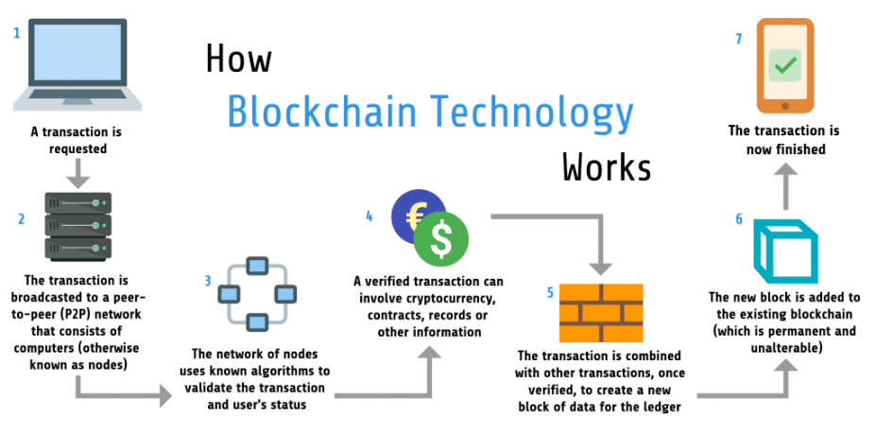

**Applications of Blockchain**

**Healthcare:**

* Secure Medical Records - With blockchain applications in healthcare, now you can publish your medical records safely on the blockchain. And, be assured that you or an authorized person can access it anywhere in the world.
* Check for Fake Medicine - Blockchain provides a solution to track pharmaceuticals throughout the supply chain. And, to ensure the consumers receive an authentic product.

**Finance:**

* Transfer Money Internationally - Blockchain applications in banking is changing the way money is sending around the world, securely and at a lower fee.
* Reduce Insurance Fraud - Insurance can be exposed to numerous fraud schemes. For example, a new applicant can commit fraud by withholding critical information. Or, by filing a claim on behalf of ineligible dependents. Record medical procedures and time stamp via blockchain platform can help reduce insurance fraud. This helps compliance and verification of medical services rendered.

**Cryptocurrency:**

* Bitcoin, Litecoin, Ethereum, Mana, Solana, Tether, etc.,
* Transaction of cryptocurrencies

**Retail:**

* Give the product its identity to verify if it is fake or not.

**Real time IOT:**

* Adopt latest IOT technology, 5G platform, blockchain to build smart cities to develop more efficient and enjoyable cities.

**Blockchain in Medical Transcription:**

Blockchain has many applications in healthcare industry. Storing patient’s medical records, medical supply chain management, tracing of drugs and their expiry. As of now, there is no organization or hospital has adopted blockchain technology in maintaining medical record. But some research papers have been published on blockchain enabled electronic medical record for doctor-patient conversations.

**References:**

* <https://www.syberscribe.com.au/blog/patient-privacy-and-confidentiality-your-responsibilities-as-a-medical-transcriber/>
* <https://www.fiercehealthcare.com/tech/32m-patient-records-breach-2019-double-all-2018-protenus-reports>
* <https://www.academia.edu/download/65275421/CSEIT206441.pdf>
* <https://www.sciencedirect.com/science/article/pii/S1110866520301365>
* Blockchain Technology Overview – NIST.IR - 8202